[ALL INDIA TENNIS ASSOCIATION]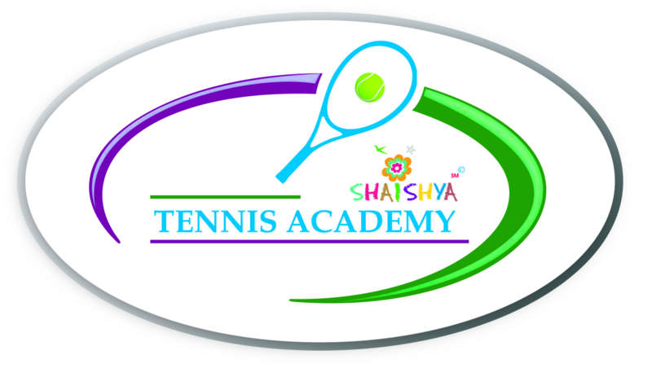
NAME OF THE TOURNAMENT | AITA SHAISHYA UNDER 10 TOURNAMENT
NAME OF THE STATE ASSOCIATION | GUJARAT STATE TENNIS ASSOCIATION
HONY. SECRETARY OF ASSOCIATION | Mr. CHINTAN PARIKH
ADDRESS OF ASSOCIATION | GUJARAT STATE TENNIS ASSOCIATION,  NEAR. SPORTS CLUB OF GUJ.LTD.  S.P. STADIUM ROAD, NAVRANGPURA. AHMEDABDA 380009
TOURNAMENT DAYS | 9th Decemeber to 11th December  (may vary as per the draw size)

THE ENTRY IS TO BE SENT by email | stagujarat@yahoo.com ;  Acceptance list will be shared 1 week before the  Event. Sign in is compulsory for all – Saturday morning.

NAME OF THE VENUE |  | SHAISHYA TENNIS ACADEMY
ADDRESS OF VENUE |  | SHAISHYA TENNIS ACADEMY,  IN LANE OF ARYAVAT IV,  IN LANE OPPOSITE YMCA  S.G. HIGHWAY,  AHMEDABAD
TELEPHONE | -9687833737,  - 9106604153 | EMAIL | (Tournament venue email: sta.tournament@gmail.com)  devinder@samasamtennis.com
COURT SURFACE | HARD COURTS – SHADED | BALLS | TBA(To be Announced)
NO. OF COURTS | 04 | FLOODLIT | YES (04)

TOURNAMENT DIRECTOR |  |  | Mr. Shrimal Bhatt
TELEPHONE |  | 9327155400 | EMAIL | shrimal@shrimalbhatt.com
REFEREE | Devinder Singh Bhusari
TELEPHONE |  | 8866050100; 91066 04153 | Email | devinder@samasamtennis.com
(Continued on next page)

HOTEL DETAILS

NAME | ADDRESS | CONTACT DETAILS
CORPORATE RESIDENCY | DEV ARC MALL, S.G.HIGHWAY | Phone: 079-26921095  98244 82357
HOTEL AVION INN | 3rd Floor, Aarambh Complex, Opp. Andaz Party Plot,  Nr. Divya Bhaskar, Makarba, S.G.Highway,  (Situated at walking distance from the venue) | +91 97141 17888  www.hotelavioninn.com
SILVER LEAF HOTEL | GORDHAN THAL, OPP RAJPATH CLUB, SARKHEJ GANDHINAGAR HIGHWAY, | +(91)-(79)-26870111
HOTEL KINGSTON | THALTEJ CROSS ROAD, SARKHEJ GANDHINAGAR ROAD, THALTEJ | +(91)-79-66153404

RESTAURANT DETAILS

NAME | FOOD | DISTANCE
HONEST | PUNJABI, SOUTH INDIAN, SNACKS | 1 K.M
HAVMOR | PUNJABI, SNACKS | 1.5 K.M.
Lots of options for restaurant available on Prahaladnagar Road – 1 k.m. from the venue
(Continued on next page)

RULES / REGULATIONS
SIGN-IN | COMPULSORY SIGN-IN ON Saturday, 9th December , 2017  Time: 9 a.m. to 10 a.m. (Compulsory for even those who have sent entry)
AGE ELIGIBILITY | Players born:  On or after 1st Jan 2007 are eligible for participation in U/10.
ENTRY FEE | SERIES SINGLES FEE DOUBLES FEE  Talent Series Rs 250/- Not applicable
DAILY ALLOWANCE | Not applicable
AITA Registration Card | Aplayer aged 7 and abo  ve will only be allowed to register and  only registered players can  participate in the 10 and under  competitions.
MATCH FORMAT | AS PER AITA RULES

